Digitech GNX1
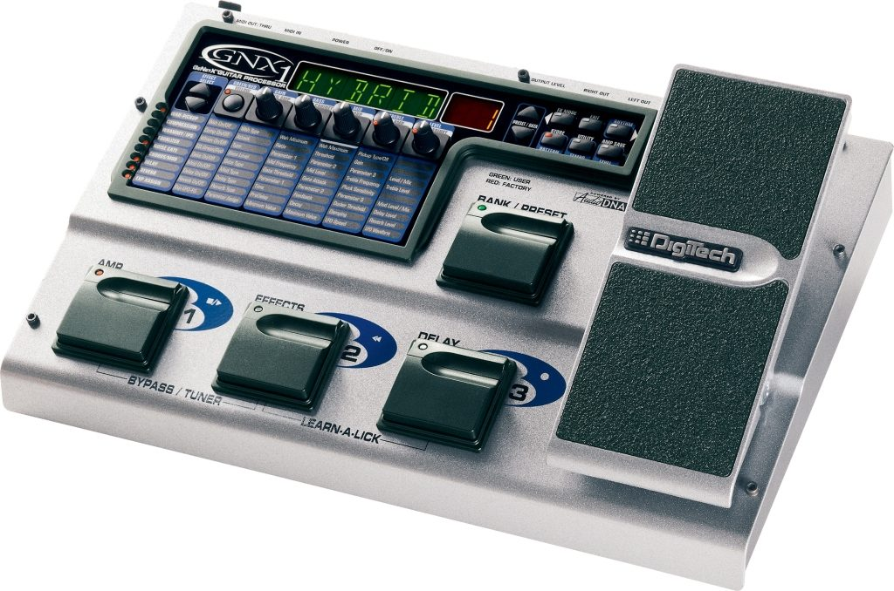

MIDI System Exclusive
by
Gary Barnes
Version 1.0 31 December 2024

Table of Contents
Introduction 4
Message Format 5
Packed Data 6
Number Format 7
Banks and Patches 7
Command Codes 9
Code 01: Device Enquiry 10
Code 02: Power On Announcement 11
Code 03: Not Documented 11
Code 04: Not Documented 11
Code 05: Status Request 11
Code 06: Response to 05 Status Request 12
Code 07: Request Amp & Cab Names 13
Code 08: Response to 07 Request Amp and Cab Names 13

Introduction
The Digitech GNX1 is a powerful vintage guitar effects processor which shipped with the GENEdit software package for editing from a Windows machine. I wanted to create a Linux of that software, and so I contacted Digitech for documentation on the MIDI System Exclusive messages which the software uses to communicate with the device. Unfortunately, Digitech had nothing they could give me, so I set about decoding the transmitted messages.
This document describes what I have discovered to date. It may not be complete but there is enough for me to build my editing software, built in the Python programming language using the Qt framework, which should mean that it is cross-platform.
My software is called GNXEdit and is available on Github as an open source project (although currently in development) at https://github.com/gary-1959/GNXEdit.

Message Format
There are many resources on the internet which detail the MIDI System Exclusive format, so I will skip that here and concentrate on the message contents applicable to the GNX1.
The general format is as follows (number is hexadecimal unless stated otherwise):
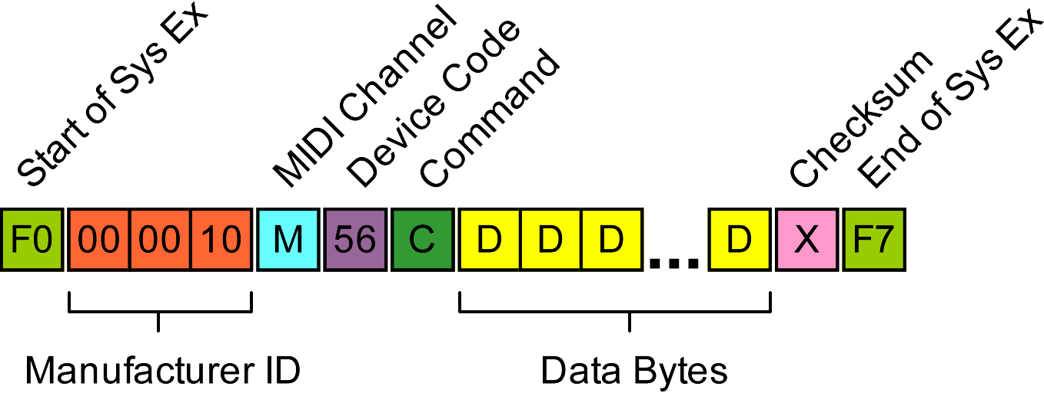
Start of Sys EX | Always 0xF0
Manufacturer ID | Three bytes 0x00, 0x00, 0x10 which is listed as the ID for DOD Electronics Corp with the Association of Musical Electronics Industry (AMIE)
MIDI Channel | 0x00 to 0x0F corresponding to MIDI channels 1 to 15 (decimal), or the broadcast code 0x7E used when probing the MIDI connection for compatible devices on any channel.
Device Code | Manufacturer’s unique identifier for the GNX1. Always 0x56.
Command | A code describing the contents of the message. This is detailed in this document.
Data Bytes | A variable number of data bytes, ususally in a packed format which is detailed in this document
Checksum | Standard System Exclusive checksum, which is an XOR sum of all the preceding bytes excluding the 0xF0 start of message code
End of Sys Ex | Always 0xF0

Because MIDI is quite a slow format, the GNX1 encodes numbers according to their size to minimise message lengths (see below). Therefore, when encoding a complete message the number values are first encoded then the complete data package is packed.

Packed Data
The MIDI protocol defines bytes with the most significant byte (MSB) set as commands. This means that byte values higher or equal to 0x80 (128 decimal) are a command of some description. This means that data bytes transmitted within a System Exclusive message are limited to the value 0x7F.
To overcome this the GNX1 uses a method of data packing consisting of a single byte containing the most significant bits of the following 7 bytes. Note that the last packed transmitted can be truncated to less than 7 bytes (no padding is used).
The first byte is constructed as follows:
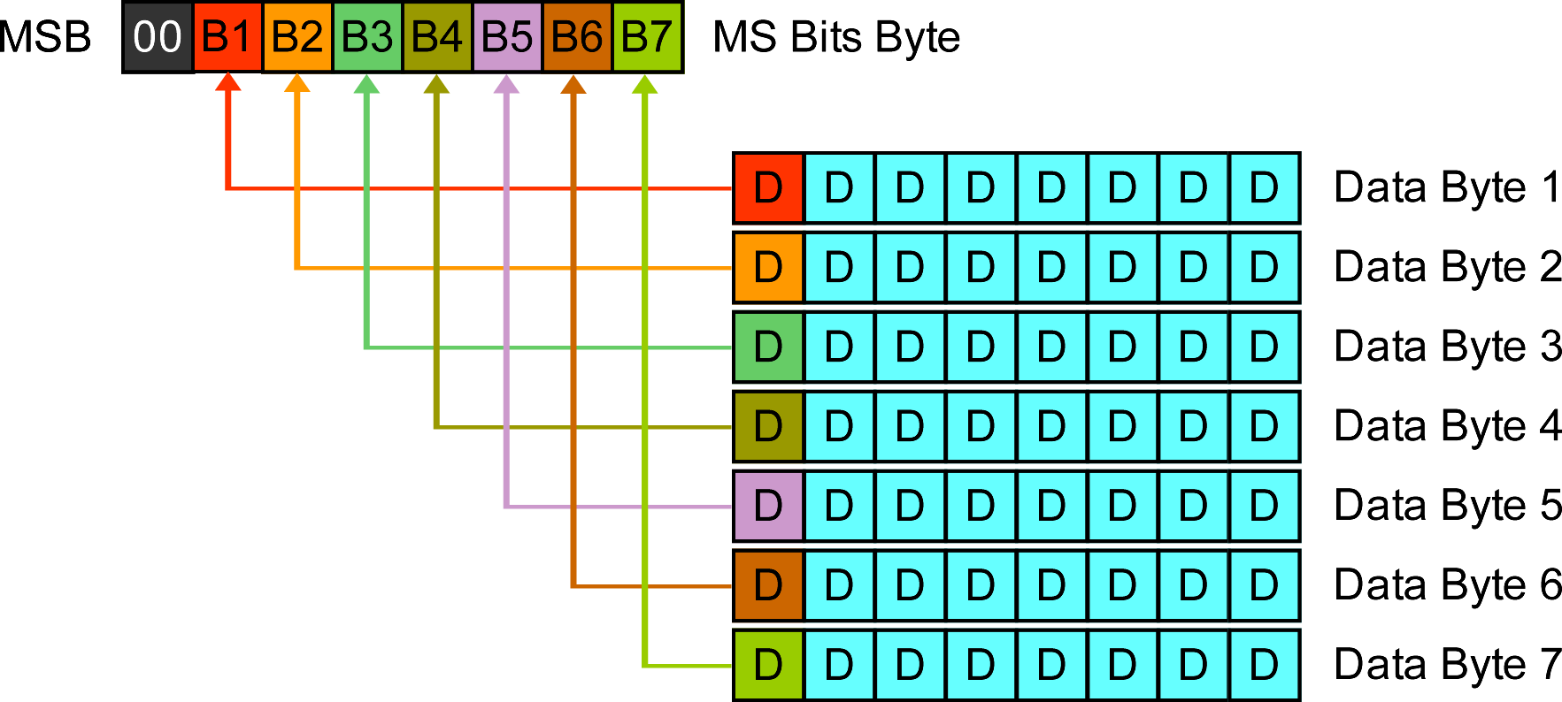
Example:
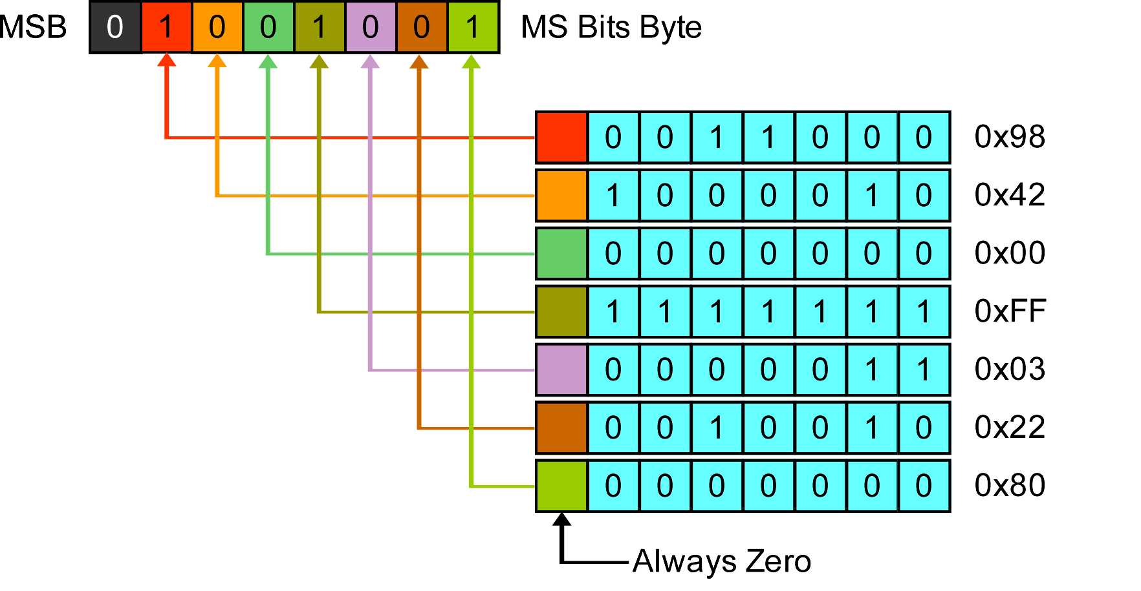
In this example the byte sequence:
 | 0x98 | 0x42 | 0x00 | 0xFF | 0x03 | 0x22 | 0x80

becomes:
0x49 | 0x18 | 0x42 | 0x00 | 0x7F | 0x03 | 0x22 | 0x00

Number Format
A further level of encoding is employed for numbers. The GNX1 transmits numerical values up to 0x7F as a single byte. For values greater than this an encoding system is used whereby the first byte has the most significant bit set and the lower bytes contain the number of bytes following which comprise the number.
Number | First Byte | Second Byte | Third Byte
0x00 to 0x7F | 0x00 to 0x7F | N/A | N/A
0x80 to 0xFF | 0x81 | 0x80 to 0xFF | N/A
0x0100 to 0x01FF | 0x82 | 0x01 | 0x00 to 0xFF
0xFFFF | 0x82 | 0xFF | 0xFF

Banks and Patches
Many commands refer to a particular bank (Factory, User, Buffer) and patch.
The User and Factory banks can have up to 48 (decimal) patches. The Buffer bank can only refer to the single edit buffer which is where patches are loaded and edited before saving to a User or Factory patch.
Banks are numbered as follows:
0x00 Factory
0x01 User
0x02 Edit Buffer
Patches are numbered 0x00 – 0x2F (0 – 47 decimal) corresponding to the User and Factory bank patches numbered 1 – 48 (decimal) on the GNX1 display. The Edit Buffer always references patch 0x00

Command Codes
These are the command codes as understood to date:
Code (Hex) | Description
01 | Device enquiry broadcast on all channels to any device
02 | Transmitted when power applied to the device
03 | Not documented
04 | Not documented
05 | Status request
06 | Response to code 05 status request
07 | Request Amp and Cab names
08 | Response to code 07 Amp and Cab names

Code 01: Device Enquiry
Broadcast on all channels to find a device on the MIDI connection.
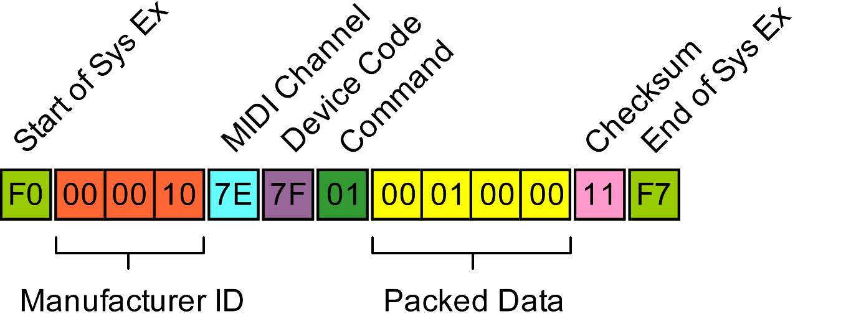
GNX1 responds with device code and MIDI channel.
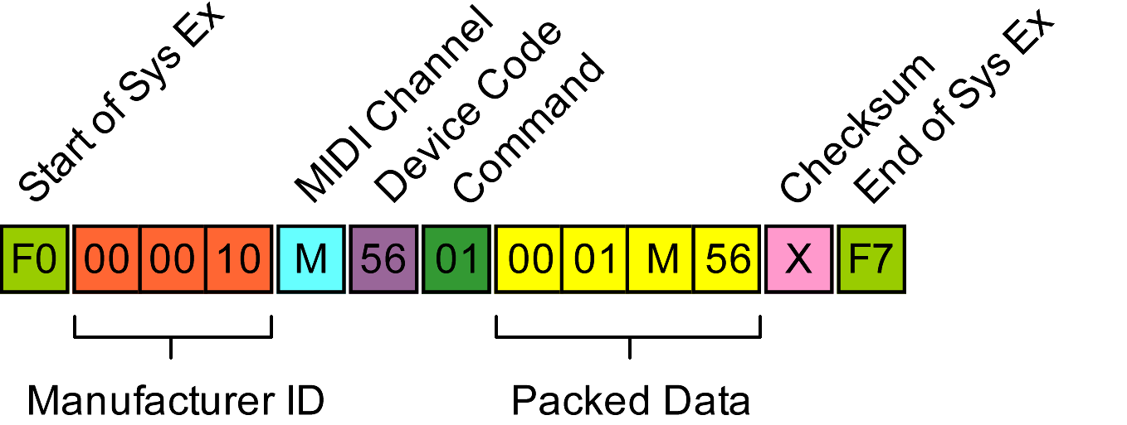
The device MIDI channel is repeated in the M data byte followed by the device code (0x56).
Note that none of the trailing 3 data bytes will be larger than 0x7F so the first data byte will always be zero. The next three data bytes are unchanged when unpacked.

Code 02: Power On Announcement
The following message is transmitted by the GNX1 when powered on:
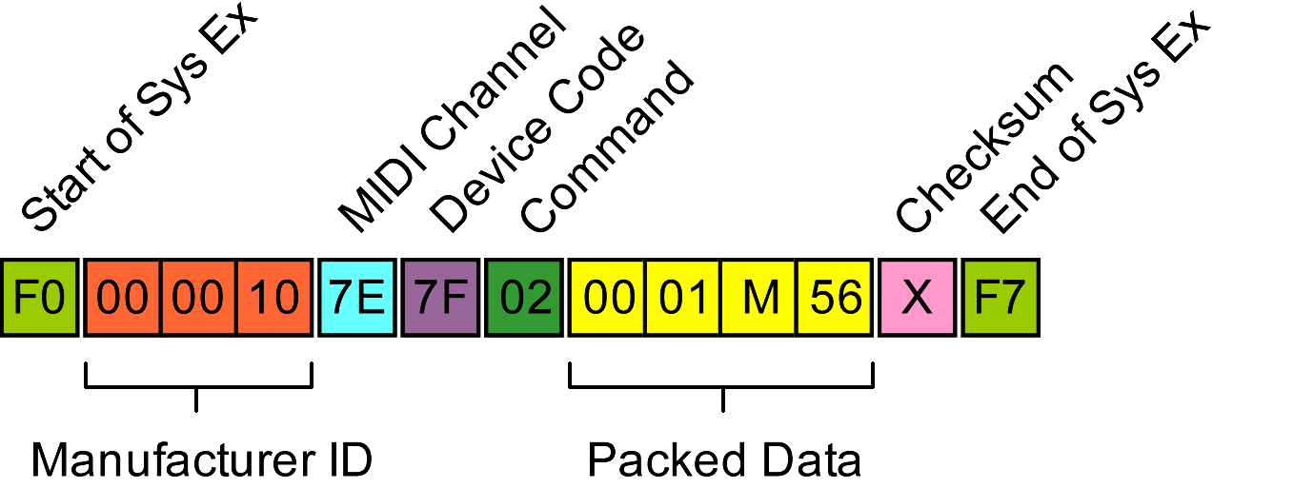
The device MIDI channel is contained in the M data byte followed by the device code (0x56).

Code 03: Not Documented
This code has not been documented.

Code 04: Not Documented
This code has not been documented.

Code 05: Status Request
Response is a code 06 message
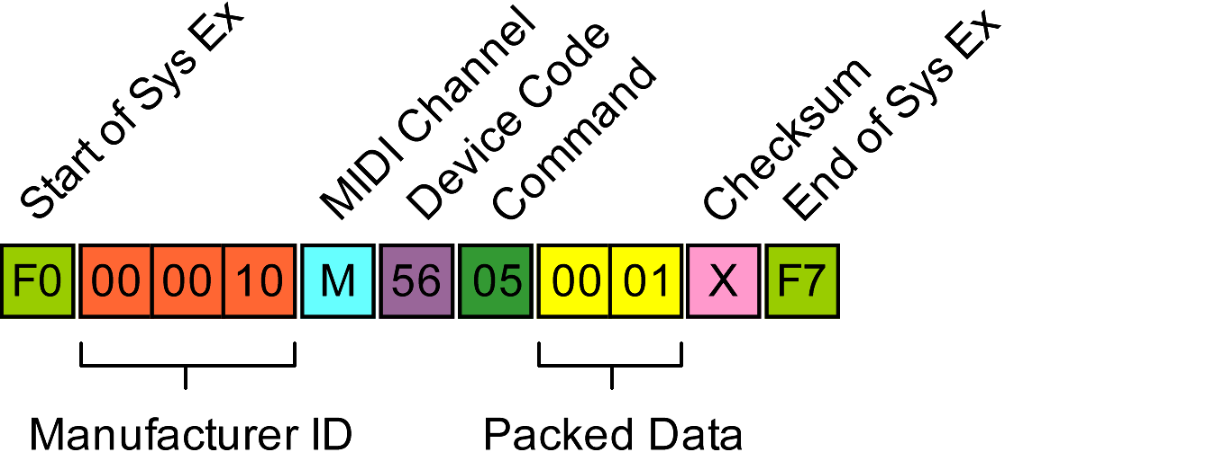

Code 06: Response to 05 Status Request
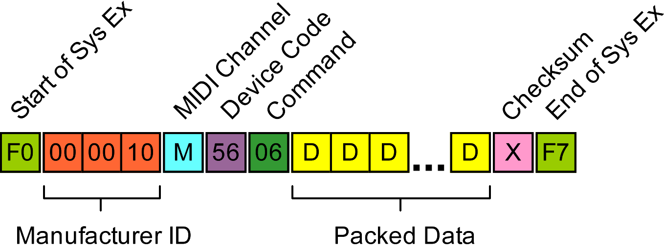
Typical response (packed data):
01 00 6F 00 15 00 25 30 . . o . . . % 0
30 03 01 06 01 01 02 01 0 . . . . . . .
05 01 06 01 07 01 08 02 . . . . . . . .
09 01 0A 02 0B 01 0C 01 . . . . . . . .
0D 01 0E 01 0F 01 10 01 . . . . . . . .
11 01 12 01 13 01 14 01 . . . . . . . .
15 01 20 01 21 01 22 01 . . . ! . " .
23 01 24 02 25 01 26 02 # . $ . % . & .
27 01 28 01 29 01 2A 01 ' . ( . ) . * .
2B 01 2C 02 2D 01 2E 01 + . , . - . . .
70 01 71 01 72 01 73 01 p . q . r . s .
74 01 75 01 76 01 7E 01 t . u . v . ~ .
7F 01

: Current Bank (00: Factory, 01: User)
: Current Patch Number (0x00 – 0x3F)
: Permitted Command Code

Following bank and patch there is an index of what appear to be accepted command codes ( ) followed by 0x01 or 0x02. Note absence of codes 0x03 and 0x04.

Code 07: Request Amp & Cab Names
Request amp and cab names
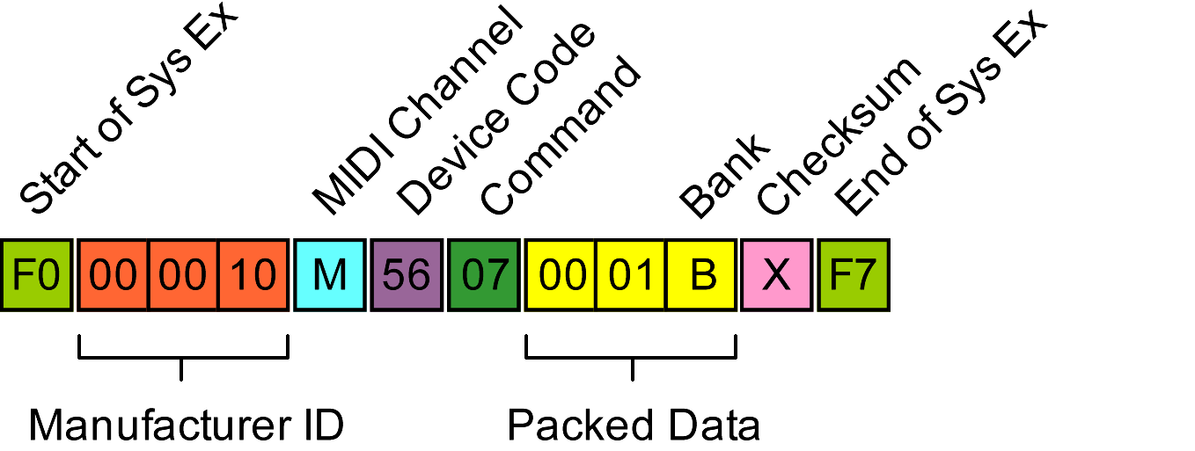
Bank is 0x00 for factory amp and cab names or 0x01 for user patches

Code 08: Response to 07 Request Amp and Cab Names
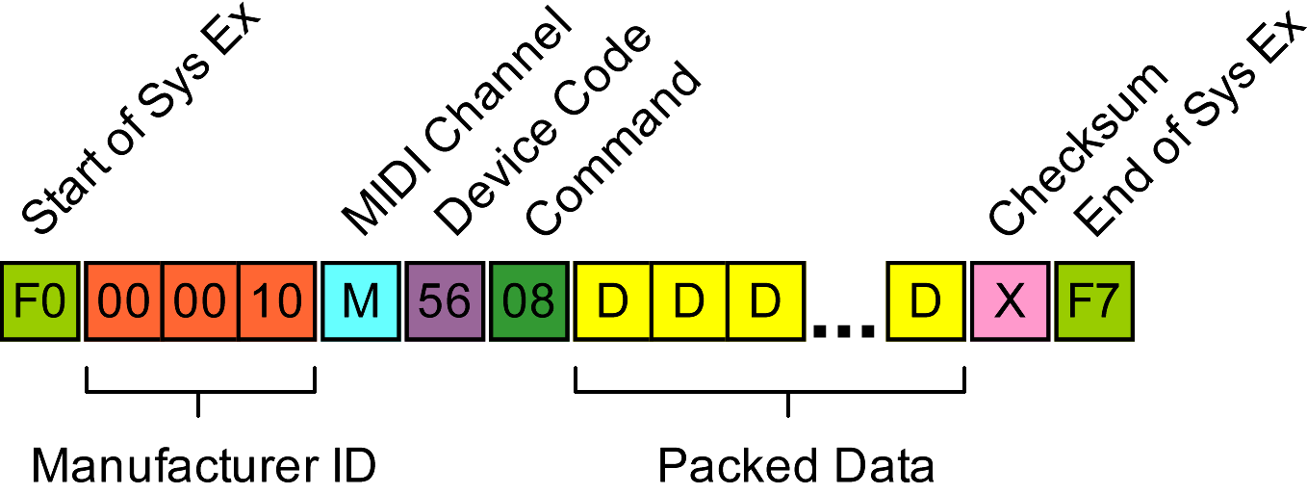
Response is an indexed list of amp and cab names. Each list is prefixed with a type code: 0x3C for amp names, 0x3D for cab names followed by a number indicating the start of the user list, then the number of names that follow. The GNX1 transmits 17 (decimal) factory amp names followed by 9 cab names. The user set is 5 each of amps and cabs.
An example response follows:

Example Response to code 07 request for Amp and Cab Names (factory, unpacked):
02 00 02 3C 11 11 00 44 . . . < . . . D
49 52 45 43 54 00 01 42 I R E C T . . B
4C 4B 46 41 43 00 02 42 L K F A C . . B
Amp Names
KEY

: 00 = Factory, 01 = User
: 3C = Amps, 3D = Cabs
: Offset to User Names
: Number of items
: Index No.
: ASCII Name
: String terminator (null)

4F 55 54 49 51 00 03 52 O U T I Q . . R
45 43 54 49 46 00 04 48 E C T I F . . H
4F 54 52 4F 44 00 05 54 O T R O D . . T
57 45 45 44 20 00 06 42 W E E D . . B
52 54 43 4D 42 00 07 43 R T C M B . . C
4C 4E 54 55 42 00 08 42 L N T U B . . B
52 54 53 54 4B 00 09 43 R T S T K . . C
52 55 4E 43 48 00 0A 48 R U N C H . . H
49 47 41 49 4E 00 0B 42 I G A I N . . B
4C 55 45 53 20 00 0C 4D L U E S . . M
4F 44 47 41 4E 00 0D 46 O D G A N . . F
55 5A 5A 20 20 00 0E 42 U Z Z . . B
41 53 53 4D 4E 00 0F 48 A S S M N . . H
49 57 41 54 47 00 10 41 I W A T G . . A
43 4F 55 53 54 00 3D 09 C O U S T . = .
09 00 44 49 52 45 43 54 . . D I R E C T
00 01 41 4D 32 58 31 32 . . A M 2 X 1 2
Cab Names
00 02 42 52 34 58 31 32 . . B R 4 X 1 2
00 03 56 20 34 58 31 32 . . V 4 X 1 2
00 04 42 52 32 58 31 32 . . B R 2 X 1 2
00 05 41 4D 31 58 31 32 . . A M 1 X 1 2
00 06 42 4C 32 58 31 32 . . B L 2 X 1 2
00 07 46 4E 34 58 31 32 . . F N 4 X 1 2
00 08 47 52 34 58 31 32 . . G R 4 X 1 2
00 .

